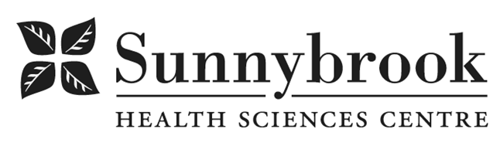
Registered Practical Nurse

Competition # |  | Location: | Bayview Campus
Classification: |  | Department: | Oncology Urgent Care Clinic (ONUC) & C2
Salary: |  | Union: | SEIU Service
Hours of Work: | Weekdays: 8 hour shifts, 1000-1800, with flexibility, as per schedule

Oncology Urgent Care Clinic (ONUC):

Exciting RPN opportunity to join the Medical Oncology Urgent Care Clinic team that provides an
alternate avenue for oncology patients to be seen for acute issues outside of the ED or
regular scheduled visits with their provider.
C2 Unit Profile:

C2 is a 36 bed unit and is part of the Odette Cancer Program at Sunnybrook Health Sciences Centre. The patient population mix for is Medical Oncology, Haematology, Radiation Oncology from all various disease sites.

There is a large inteprofessional team including social work, PT, OT, chaplaincy, Nutrition, SLP, Discharge planner, Advanced Practice nurse, Physician Assistant and Physicians.

Staff nurses are supported in their professional growth and development to acquire the knowledge, judgment and skills to care for this patient population. Growth and leadership development is supported and nurses are mentored to achieve their professional advancement goals. This includes opportunities to team lead, participate in unit and corporate based committees, be a preceptor for nursing students and engage in quality improvement projects. Nursing staff are encouraged to participate in learning opportunities internally and externally at the local, national and international level.

Summary of Duties:

Reporting to the PCM the RPN, within the RPN scope of practice, will provide a broad range of nursing/person centred care services in the ONUC clinic and to provide support as needed for the C2 inpatient unit. The RPN works collaboratively with Registered Nurses (RNs) in a consultative relationship to provide elements of care to patients with complex health issues and with less predictable outcomes.
The RPN supports the philosophy of the person centred care concept and principles and the Mission and Values of Sunnybrook Health Sciences Centre. The RPN works independently and interdependently as part of the interprofessional health care team to provide excellent culture-sensitive nursing care to patients with varying health needs in a rapidly changing, practice environment.

Responsibilities include but are not limited to:
- Care processes which include identifying the needs of patients and families
- Completing assessments, planning and continuously reassessing care
- Implementing evidence based interventions, and evaluating patient outcomes and the patient experience
- Demonstrate commitment to quality improvement, ongoing professional development and reflective practice
Qualifications/Skills:
- Current registration in good standing with the College of Nurses of Ontario with no restrictions to practice as a Registered Practical Nurse
- Current Heart and Stroke Foundation CPR
- RPN diploma preferred
- IV insertion, phlebotomy skills required
- Two (2) years recent acute care nursing experience preferred or recent RPN experience plus successful completion of the Sunnybrook Advanced Assessment Course for RPN’s at Humber within the last 2 years.
- Demonstrated commitment to Person-Centred Care
- Demonstrated critical-thinking, decision-making, and problem solving skills in a fast a fast paced, high turnover environment
- Demonstrated interpersonal, communication and teamwork skills
- Evidence of ongoing commitment to professional practice and support of a quality practice setting environment
- Demonstrated knowledge of and commitment to safe, high quality, ethical care
- Demonstrated ability to identify when care needs of patient and family have changed and require a broader scope of knowledge, skill and judgment
- Demonstrated ability to plan and provide patient education to support discharge planning
- Demonstrated ability to organize and prioritize patient care assignments within the RPN scope of practice collaboratively with RNs and other members of the inter-professional team
Date Posted:
Last Day for Application:

- The location and/or details in the job posting may change depending on operational needs.
- Qualified Applicants must submit both an Internal Application/Transfer Form and current Résumé to the Human Resources Department at their campus. Qualifications, skills and demonstrated satisfactory attendance and performance are considered as part of the selection process.
- Sunnybrook is committed to providing accessible employment practices that are in compliance with the Accessibility for Ontarians with Disabilities Act (‘AODA’). If you require accommodation for disability during any stage of the recruitment process, please indicate this on your Internal Application/Transfer Form.





