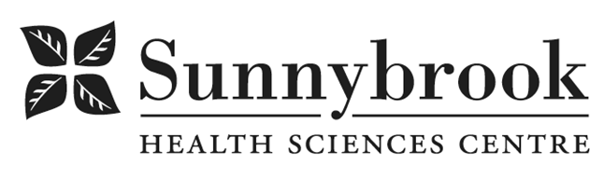
Clinical Dietitian
Competition # |  | Location: | Bayview/CNIB
Classification | 1.0 permanent FT | Department: | Nephrology
Salary: |  | Union: | Non-union
Hours of work: Weekdays, days and evenings, 8 hr shifts, as per schedule

Summary of Duties:
The Clinical Dietitian provides nutrition management for patients living with Chronic Kidney Disease across the continuum of care, in accordance with Clinical Nutrition care standards and the Patient-Focused Care standards of Sunnybrook Health Sciences Centre. As part of Sunnybrook’s Outpatient Nephrology Program, the Dietitian will deliver high-quality nutrition care to support patient health and treatment outcomes. The successful candidate will contribute to advancing patient care by attending interprofessional rounds, participating in unit-based and organizational committees, and engaging in quality improvement initiatives and practice-based research. They will also be an active member of the clinical nutrition team, contributing to the development and updating of nutrition resources used within the program. In addition, the candidate may participate in Sunnybrook’s dietetic internship program by supporting the education and training of dietetic interns. This may include serving as a preceptor or contributing in another supportive capacity.
Qualifications/Skills:
- 1–2 years of experience working with the nephrology population is preferred.
- 1–2 years of experience providing patient education, with an understanding of adult learning principles.
- Current registration in good standing with the College of Dietitians of Ontario is required.
- Excellent communication and organizational skills.
- Strong team-building and conflict resolution skills.
- Ability to work both independently and collaboratively with peers and multidisciplinary team members, while adapting to changing environments and demonstrating initiative.
- Ability to practice using a patient-focused care approach, with an understanding and appreciation of the nephrology population. Experience practicing with cultural competence is considered an asset.

- The location and/or details in the job posting may change depending on operational needs.
- Qualified Applicants must submit both an Internal Application/Transfer Form and current Résumé to the Human Resources Department at their campus. Qualifications, skills and demonstrated satisfactory attendance and performance are considered as part of the selection process.




- Sunnybrook is committed to providing accessible employment practices that are in compliance with the Accessibility for Ontarians with Disabilities Act (‘AODA’). If you require accommodation for disability during any stage of the recruitment process, please indicate this on your Internal Application/Transfer Form.

