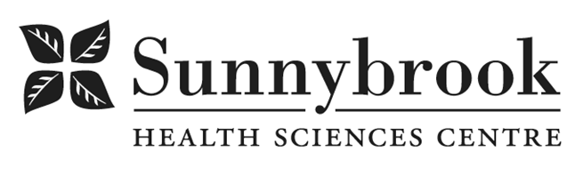
Youth Advocate with Lived Experience (YAL)

Competition # |  | Location: | 365 Bloor Street E. (hybrid)
Classification: | Full-time, Permanent | Department: | Family Navigation Project
Salary: |  | Union: N/A
Hours of Work: 37.5 hours/week

About Us:
Family Navigation Project helps youth ages 11 to 29 and their families find and access mental health and addiction supports across the GTA. We combine clinical expertise and lived experience to guide people to services that fit their needs. Our services are free and offered by phone, email, and Zoom.
We are building a team that reflects the diverse young people we support. Youth who identify as Black, Indigenous, 2SLGBTQIA+, racialized, disabled, or part of any equity-deserving group are encouraged to apply.
About the Role:
We are looking for a Youth Advocate with Lived Experience; someone who has personally navigated mental health and/or substance-use challenges as a young person and wants to support other youth on their journey.
This is a peer-support role, not a clinical role. Peer support is a non-clinical, relationship-based role that draws on lived experience to offer emotional support, validation, hope, and practical insight. We will provide training, mentorship, and ongoing support to help you share your lived experience in a way that protects your well-being and supports youth.
In this role, you will use your lived experience in a safe, intentional, and professional way, help youth feel less alone, and support them in learning how to navigate the system and advocate for themselves. You will also bring youth voice into program decisions and youth-focused projects.
This position reports to the Program Manager.
Why This Role Matters:
Youth deserve support from people who get it. Your voice, your story, and your perspective will help young people feel seen and supported, and will help make accessing the mental-health system easier for youth.

What You Will Do:
Youth Support
- Offer emotional support, encouragement, and lived-experience insight.
- Help youth understand services, options, and next steps alongside their Navigator.
- Share your lived experience in a safe and healthy way to give hope and help youth feel understood.
- Support youth in building confidence, trust, and self-advocacy skills.
- Document notes and collaborate with the team to ensure youth receive the support they need.

Youth Voice & Community Engagement
- Support youth-focused workshops, events, and community outreach.
- Bring youth perspectives into team conversations and planning.
- Represent lived experience in meetings and presentations.

Youth Advisory Council (YAC)
- Lead and support the Youth Advisory Council.
- Recruit, onboard, and mentor Youth Advisors.
- Plan and run monthly YAC meetings and youth-led projects.
- Help youth advisors share feedback and ideas to shape FNP services.

What You Bring (Required):
- Personal lived or living experience with mental-health and/or substance-use challenges as a young person.
- Open to sharing parts of your lived experience in ways that support and empower youth, while maintaining healthy boundaries.
- Ability to connect with youth ages 11-29 from different backgrounds and identities.
- Strong communication, listening, and relationship-building skills.
- Reliable with scheduling, notes, and follow-through.
- Open to learning, asking questions, receiving feedback, and working in a team

Assets (Nice to Have)
- College diploma or university degree in a related field (community services, health, social sciences)
- Experience in community, youth, or advocacy work
- Knowledge of mental-health or addiction supports in the GTA
- Peer-support training (or interest in completing training)
- Experience supporting marginalized or under-served youth communities

Date Posted:

Last Day for Application:

- The location and/or details in the job posting may change depending on operational needs.
- Qualified Applicants must submit an Internal Application/Transfer Form, Cover Letter and current Résumé to the Human Resources Department at their campus. Qualifications, skills and demonstrated satisfactory attendance and performance are considered as part of the selection process.
- Sunnybrook is committed to providing accessible employment practices that are in compliance with the Accessibility for Ontarians with Disabilities Act (‘AODA’). If you require accommodation for disability during any stage of the recruitment process, please indicate this on your Internal Application/Transfer Form.





