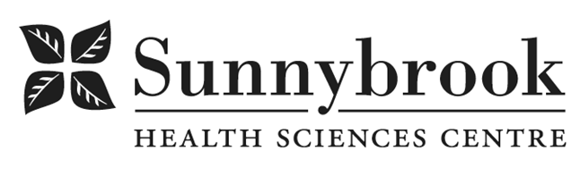
Advanced Practice Radiation Therapist, Adaptive Radiation Therapy

Competition # |  | Location: | Bayview campus
Classification: | Regular Full-Time | Department: | Radiation Therapy
Salary: |  | Union: | Non-Union
Hours of Work: | Weekdays, Days, 8 hrs; As per schedule

Summary of Duties:
The Clinical Specialist Radiation Therapist (CSRT) functions as a self-regulated, independent practitioner with a primary focus on Adaptive Radiotherapy (ART) across disease sites. This Advanced Practice role is designed for a registered Radiation Therapist (RTT) who has acquired advanced knowledge and skills through a combination of formal education (Master’s degree), workplace learning, and professional development. The CSRT will play a key role in the development, implementation, and evaluation of adaptive radiotherapy protocols and will contribute to clinical trials and research initiatives in this rapidly evolving area.

Key Responsibilities:

Adaptive Radiotherapy Leadership
- Serve as a radiation therapy expert and liaison for all interprofessional teams involved in Adaptive Radiotherapy.
- Lead and support the development, implementation, and evaluation of adaptive radiotherapy protocols, workflows, and clinical pathways.
- Provide technical and dosimetric consultation to RTTs regarding image guidance, anatomic segmentation, and adaptive treatment decision-making.
- Collaborate with physics, radiation therapy, and physician partners to optimize ART planning, QA processes, and treatment delivery.
- Contribute to the design, activation, and conduct of adaptive radiotherapy clinical trials, including protocol development, data collection, and knowledge translation.

Education, Quality, and Research
- Lead and participate in research and quality improvement initiatives related to adaptive radiotherapy and emerging technologies.
- Provide leadership, education, and support to RTTs in planning and treatment delivery for new ART protocols, techniques, and equipment.
- Identify opportunities for supplemental staff training and collaborate with the education team to develop and implement targeted learning opportunities.
- Support the development of Person-Centred educational materials and resources related to adaptive radiotherapy.

Patient Care and Quality Assurance
- Provide ongoing support for patients undergoing adaptive radiotherapy from initial consultation through treatment and follow-up.
- Ensure Quality Assurance procedures are maintained for all aspects of patient care within ART workflows.
- Promote and model Person-Centred Care principles in all interactions with patients, families, and caregivers.

Qualifications/Skills
- Successful completion of a baccalaureate from an accredited radiation therapy program
- Registered and in good standing with the College of Medical Radiation and Imaging Technologists of Ontario (CMRITO).
- Minimum 5 years experience as an RTT.
- Current CPR certificate is required.
- Completion or enrolled in a Master’s level or higher degree are considered an asset (the successful candidate will be expected to complete a Master’s degree as condition of acceptance of position).
- Willingness to work towards APRT(T) certification.
- Strong interpersonal skills and the ability to work both independently and within an interprofessional team.
- Demonstrated commitment to Person-centred Care approaches and principles.
- Strong knowledge base of radiation treatment techniques, including ART, capabilities of radiation therapy technologies and management of radiation therapy related side effects are considered an asset.
- Proficiency in teaching, research or quality improvement, project development and management, and effective presentation skills will be viewed as an asset.

Date Posted:
Last Day for Application:
- The location and/or details in the job posting may change depending on operational needs.
- Qualified Applicants must submit both an Internal Application/Transfer Form and current Résumé to the Human Resources Department at their campus. Qualifications, skills and demonstrated satisfactory attendance and performance are considered as part of the selection process.
- Sunnybrook is committed to providing accessible employment practices that are in compliance with the Accessibility for Ontarians with Disabilities Act (‘AODA’). If you require accommodation for disability during any stage of the recruitment process, please indicate this on your Internal Application/Transfer Form.

