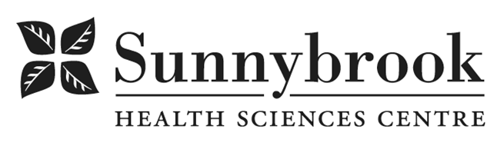
Digital Communications Student

Competition # |  | Location: | Bayview Campus
Classification: | Temporary Full Time | Department: | Strategic Communications
Salary: | To Be determined | Union: | Non-Union
Hours of Work: Weekdays, 8hrs

About the Strategic Communications Team
Strategic Communications is a collaborative team of communicators, graphic designers, photographers/videographers, and digital and web specialists dedicated to advancing our organization’s mission through clear, compelling, accessible, and engaging communications. We support internal and external communications, digital strategy, reputation management, media relations, branding, stakeholder engagement, and online content. The team works across all programs, community partners and works collaboratively with the Sunnybrook Foundation.
As part of this team, the Digital Communications Student will play a key role in transforming complex medical and clinical information into accessible digital content for patients, families, and caregivers. This role directly supports the development of high-quality patient education materials on our website and contributes to the creation of standards, templates, and processes that strengthen our digital patient facing content.

Position Overview
We are seeking a highly motivated, detail-oriented Digital Communications Student with strong writing, digital content creation, and technical skills. The ideal candidate is passionate about health literacy, clarity in communication, and digital user experience. This individual is comfortable working with subject-matter experts, translating clinical information into patient-friendly language, and supporting web publishing tasks (including WordPress backend work).
This role is well-suited for someone who thrives at the intersection of content, design, technology, and patient-centered communication.
Summary of Duties:

Patient Education Content Development:
- Translate complex clinical or medical information into clear, accessible, patient-friendly digital content in collaboration with clinical leaders and Strategic Communications team members
- Research, write, edit, and structure health education materials for the website, including program-specific patient resources.
- Work closely with clinicians, program teams, and Communications Advisors to ensure accuracy, clarity, and alignment with organizational standards.
- Apply health literacy principles, plain language standards, Canadian Press style, and accessibility best practices (e.g., AODA).

Digital Content Standards, Templates & Governance
- Assist in developing templates, guidelines, and editorial standards for patient education content.
- Support the creation of a consistent content governance model, including workflows, approval processes, and documentation.
- Help develop and maintain internal policies related to patient education content, digital tone, and accessibility.

Website & Technical Support (WordPress)
- Assist with updating, publishing, and maintaining patient education content on the website using WordPress.
- Support back-end content management tasks, including organizing pages, metadata, tagging, SEO basics, and ensuring proper formatting.
- Conduct quality assurance checks, testing functionality, optimizing layout, and ensuring content accuracy.
- Assist with troubleshooting minor web issues and collaborate with web team as required.

Additional Communications Support
- Collaborate with Strategic Communications staff on broader digital communications initiatives as required.
- Participate in planning meetings, content discussions, and project reviews.
- Support other web and digital media needs related to patient-facing information.
Qualifications/Skills
- Currently enrolled in a post-secondary program in Digital Communications, Communications, Journalism, Media Studies, Health Communication, UX Design, Web Content Management, or a related field.
- Strong writing and editing skills with the ability to translate technical or clinical information into accessible, engaging content for the public.
- Experience using WordPress or similar content management systems; comfort with basic HTML is an asset.
- Understanding of plain language, Canadian Press style, health literacy principles, and accessibility standards (AODA/WCAG).
- High attention to detail, strong organizational skills, and ability to manage multiple tasks in a deadline-driven environment.
- Excellent interpersonal skills and confidence working with subject-matter experts.
- Familiarity with digital content best practices, including SEO, UX principles, and structuring content for the web.
- Ability to work independently and collaboratively in a fast-paced, supportive team environment.

Date Posted:
Last Day for Application:

- The location and/or details in the job posting may change depending on operational needs.
- Qualified Applicants must submit both an Internal Application/Transfer Form and current Résumé to the Human Resources Department at their campus. Qualifications, skills and demonstrated satisfactory attendance and performance are considered as part of the selection process.
- Sunnybrook is committed to providing accessible employment practices that are in compliance with the Accessibility for Ontarians with Disabilities Act (‘AODA’). If you require accommodation for disability during any stage of the recruitment process, please indicate this on your Internal Application/Transfer Form.

