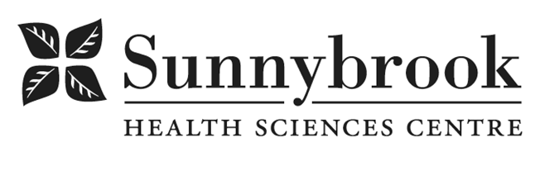
Sr. Stores Receiver

Competition # |  | Location: | St. John’s Rehab
Classification: |  | Department: | Supply Chain Services
Salary: |  | Union: | SEIU Service
Hours of Work:

Summary of Duties
Responsible for General Receiving, Stores, and supply rooms duties described below.

- Ensures all incoming shipments contain appropriate packing slips, hospital purchase order (PO) and pieces delivered match carrier/courier delivery documents
- Responsible for the daily keying and input of all packing slips to ensure the goods received in the system match the PO to facilitate invoice payment
- Ensures prompt delivery of all incoming shipments to internal recipients as per the PO
- Maintains optimal stock levels for assigned supply carts. Rotates and manages inventory to minimize obsolescence and shortages.
- Scans supply carts for replenishment, to ensure appropriate stock levels to support units.
- Receives and puts away incoming replenishment orders from Mohawk Medbuy DC.
- Reconciles stock replenishment orders with supplies received for supply carts and reports discrepancies to Mohawk Medbuy.
- Responsible for Stores charge-outs and reconciliation of Reservations with available inventory
- Assists other Sr. Stores Receiver as necessary and provides coverage for breaks
- Works in a professional and team focused approach with all hospital staff and service areas
- Other supply chain duties as identified by Management

Qualifications/Skills
- Secondary School graduation
- Knowledge of medical/surgical supplies
- Successful experience working in Healthcare Materials Management setting
- Strong customer service sense and skills
- Exceptional communication & interpersonal skills
- Must have exceptional accuracy and attention to detail
- Must have excellent work attendance
- Must be able to work in a fast-paced physically demanding environment.

Date Posted:
Last Day for Application:

- The location and/or details in the job posting may change depending on operational needs.
- Qualified Applicants must submit both an Internal Application/Transfer Form and current Résumé to the Human Resources Department at their campus. Qualifications, skills and demonstrated satisfactory attendance and performance are considered as part of the selection process.
- Sunnybrook is committed to providing accessible employment practices that are in compliance with the Accessibility for Ontarians with Disabilities Act (‘AODA’). If you require accommodation for disability during any stage of the recruitment process, please indicate this on your Internal Application/Transfer Form.





