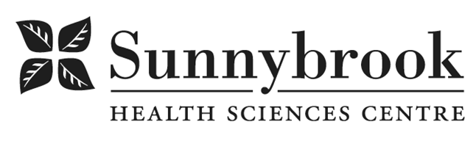

Nurse Practitioner – Cognitive Neurology
Competition # |  | Location: | Hurvitz Brain Sciences Program
Classification: | Temporary Full-time (2 Years) | Department: | Barzakay Clinic
Salary: |  | Union: | Non-Union
Hours of Work: | Weekdays; Days; 8 hrs; As per schedule

Summary of Duties

The Nurse Practitioner is an advanced practice role designed to contribute to the quality of patient care through practice, research and education. In addition to direct patient care, this position will focus on the development of policies, procedures and risk management processes. Direct patient care with focus on assessment and management of cognitive disorders (e.g. dementia, alzheimer’s disease, lewy body dementia, etc.). Performs and interprets comprehensive cognitive, functional and behavioral assessments (MMSE/MOCA), supports care navigation, while monitoring disease progression and initiates or adjusts treatment plans accordingly. The Nurse Practitioner is an integral member of the interprofessional team and serves as a role model and mentor for other staff. The Nurse Practitioner reports to the Operations Director.

Qualifications/Skills
- Current College of Nurses of Ontario Certificate of Competence
- Master’s degree with Certification in the Extended Class (RN-EC Adult) from the College of Nurses of Ontario
- Current B.C.L.S. Certification
- Membership in NPAO
- Demonstrated clinical expertise and experience in cognitive disorders, including assessment, diagnosis and management of dementia and other related neurological disorders and/or long-term/geriatric care
- Demonstrated ability to collaborate effectively with neurologists and interprofessional team members (RN, OT, SW) and community partners to optimize patient centred care.
- Three years experience as a Nurse Practitioner in acute care or outpatient setting, focused on cognitive neurology preferred
- Knowledge and experience in pharmacologic and non-pharmacologic management of cognitive disorders including behavioral and psychological symptoms of dementia.
- Demonstrated program planning and evaluation skills
- Demonstrated research and evidence-informed practice abilities
- Proven professional leadership and ability to support innovation and advanced practice role development.
- Strong interpersonal, communication, consultation, and care coordination skills.
- Demonstrated knowledge and experience in quality management activities

Date Posted:
Last Day for Application:

- The location and/or details in the job posting may change depending on operational needs.
- Qualified Applicants must submit both an Internal Application/Transfer Form and current Résumé to the Human Resources Department at their campus. Qualifications, skills and demonstrated satisfactory attendance and performance are considered as part of the selection process.
- Sunnybrook is committed to providing accessible employment practices that are in compliance with the Accessibility for Ontarians with Disabilities Act (‘AODA’). If you require accommodation for disability during any stage of the recruitment process, please indicate this on your Internal Application/Transfer Form.





