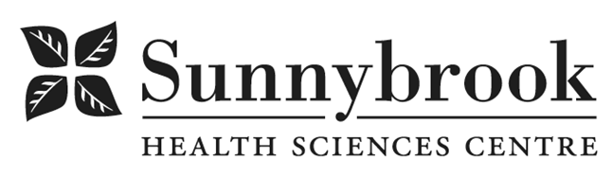

Human Resources Business Partner

Competition # |  | Location: | This role can be performed fully onsite or on a hybrid work model, in compliance with the Hospital’s Work from Home Policy (#HR-229)
Classification: | Temporary Full-time | Department: | Human Resources
Salary: | $41.13 - $52.55/hr | Union: | Non-Union
Hours of Work: Monday– Friday, with flexibility to meet client needs as required

Reporting to the Director of Labour Relations, the Human Resources Business Partner is accountable to:

Summary of Duties
- Operationalize HR strategies and initiatives that meet the needs of the client group and the organization
- Bring value-added professional HR advice and counsel to leadership in areas of recruitment, conflict resolution, labour and employment matters, grievance handling and other HR issues
- Act as a resource to employees on HR issues
- Lead and/or participate in the executing of various components of the Corporate Human Resources Strategy to enhance service delivery within the organization
- Maintain an on-going relationship with local union representatives and recommend approaches for early identification and resolution of potential problems
Qualifications/Skills
- Degree in Human Resources, Business, Hospital Administration or related discipline required.
- Professional Human Resources certification is considered an asset
- At least 5 years related Human Resources Business Partner or equivalent experience in a customer focused Human Resources Department, including significant labour relations experience in a multi-union environment required. Must also have experience in areas of employment law, employee, grievance handling, recruitment, accommodation/modified work placements, conflict resolution, displacements/terminations. HR experience within the healthcare sector is strongly preferred
- Extensive knowledge of Ontario Employment Standards Act, WSIB, Human Rights Code, Labour Relations Act, Pay Equity Act, Occupational Health and Safety Act and proven ability to provide advice to clients on the application of these acts.
- Demonstrated advanced skills in investigation, analysis, coaching, negotiation, facilitation, communication, decision making, consultation, mediation, counseling, interviewing, change management.
- Demonstrated experience in developing and leading corporate-wide human resources initiatives.
- Demonstrated excellent verbal and written communication skills
- Demonstrated ability to work with diverse employee groups
- Competent computer skills (HRIS, Outlook, Microsoft Office - Word, Excel, Powerpoint, Access)
- Demonstrated excellent attendance

Date Posted:
Last Day for Application:

- The location and/or details in the job posting may change depending on operational needs.
- Qualified Applicants must submit both an Internal Application/Transfer Form and current Résumé to the Human Resources Department at their campus. Qualifications, skills and demonstrated satisfactory attendance and performance are considered as part of the selection process.
- Sunnybrook is committed to providing accessible employment practices that are in compliance with the Accessibility for Ontarians with Disabilities Act (‘AODA’). If you require accommodation for disability during any stage of the recruitment process, please indicate this on your Internal Application/Transfer Form.





