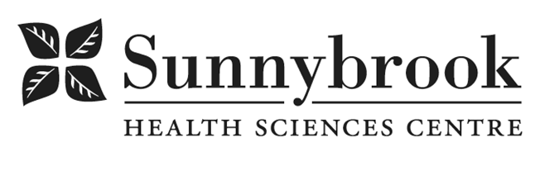
Patient Service Partner

Competition # |  | Location: | Bayview
Classification: |  | Department:
Salary: |  | Union: | SEIU Service
Hours of Work: | Weekdays:  Alternating Weekends:

Summary of Duties:
Working with the professional team, the Patient Service Partner participates in the caring of patients by providing a variety of support services to the team and patients. Participates as a member of the team in a manner that reflects the Hospital philosophy and mission of service and promotes and maintains good public relations with patients, visitors and Hospital staff. Patient Service Partner working on [unit] will be required to assist with patient care; decontamination of patients care areas and equipment.

Qualifications/Skills:
- Minimum Grade 11 or equivalent as recognized by the Province of Ontario Ministry of Education
- Applicants who have a PSW Certificate will be given priority
- Must have knowledge and ability to assist with direct fundamental patient care activities as required including ambulation, dressing, and turning/repositioning
- Sunnybrook PSP (formerly PSA) course preferred
- Recent PSP experience preferred
- Ability to read and write English
- Two (2) years of related health care experience
- Must be accustomed to high patient acuity
- Experienced with acute care setting
- Flexibility and willingness to take direction
- Excellent communication and interpersonal skills
- Proven ability to work under pressure and to handle various tasks within a limited time frame
- Must be prepared and able to use all personal protective equipment
- Liaises with patients and visitors on a regular basis demonstrating excellent customer service

Date Posted:
Last Day for Application:

- The location and/or details in the job posting may change depending on operational needs.
- Qualified Applicants must submit both an Internal Application/Transfer Form and current Résumé to the Human Resources Department at their campus. Qualifications, skills and demonstrated satisfactory attendance and performance are considered as part of the selection process.
- Sunnybrook is committed to providing accessible employment practices that are in compliance with the Accessibility for Ontarians with Disabilities Act (‘AODA’). If you require accommodation for disability during any stage of the recruitment process, please indicate this on your Internal Application/Transfer Form.

