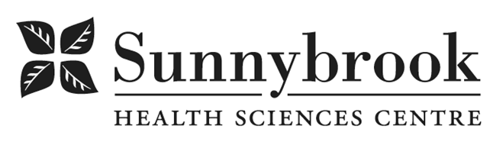

Nurse Practitioner

Competition # |  | Location: | Bayview
Classification: | Permanent Full-Time | Department: | Integrated Community Program- Endocrinology
Salary: |  | Union: | Non-Union
Hours of Work: Weekdays & Weekends: Days, Evenings; 8 hours; As per Schedule. Flexibility Required.
Summary of Duties:
The Nurse Practitioner is an advanced practice role designed to contribute to the quality of patient care through practice, research and education.

The current emphasis of this role is direct patient care, including the daily clinical management and coordination of interdisciplinary patient care of a defined group of patients with complex diabetes needs in both inpatient (NP consults and same day surgery) and outpatient settings (specifically the RADAR Clinic and the ADP Pump Program). Collaborates with Endocrinologists, Diabetic Nurse Educator, Nurse Practitioners, Patient Care Managers, Advanced Practice Nurse, all members of the inter-professional clinical team, NP Professional Practice Leader, as well as those of the various consult services and Nursing to enhance and improve nursing practice and the diabetic management of patients.

Qualifications/Skills:
- RN (EC) license, current College of Nurses of Ontario Certificate of Competence in good standing
- Certified Diabetic Educator (CDE) required
- Master’s degree with Nurse Practitioner Certification required
- 5 years experience in diabetes education required
- Certified insulin pump trainer required (CPT)
- Demonstrated clinical expertise in diabetes management.
- Recent experience in all diabetes treatment modalities
- Current B.C.L.S.
- Membership in R.N.A.O.
- Previous experience as a Clinical Nurse Specialist/Nurse Practitioner an asset
- Program planning and evaluation skills
- Demonstrated research abilities
- Demonstrated professional leadership and ability to be innovative and creative
- Experience precepting undergraduate, graduate, and post-graduate students, as well as clinical fellows in their experience, and evaluating their performance.
- Strong interpersonal and communication skills

Date Posted:
Last Day for Application:

- The location and/or details in the job posting may change depending on operational needs.
- Qualified Applicants must submit both an Internal Application/Transfer Form and current Résumé to the Human Resources Department at their campus. Qualifications, skills and demonstrated satisfactory attendance and performance are considered as part of the selection process.
- Sunnybrook is committed to providing accessible employment practices that are in compliance with the Accessibility for Ontarians with Disabilities Act (‘AODA’). If you require accommodation for disability during any stage of the recruitment process, please indicate this on your Internal Application/Transfer Form.





