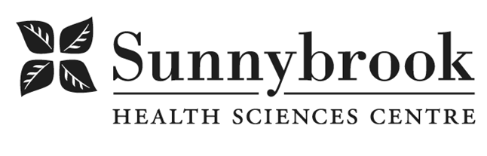

Nurse Practitioner – Endocrinology

Competition # |  | Location: | Bayview
Classification: | Permanent Full-Time | Department: | Integrated Community Program- Endocrinology
Salary: |  | Union: | Non-Union
Hours of Work: Weekdays & Weekends: Days 8 hours; As per Schedule.
Summary of Duties:
This is an exciting opportunity for a Nurse Practitioner who is interested in developing specialized expertise in diabetes while working within an experienced and supportive interdisciplinary team.
The Nurse Practitioner will lead the clinical delivery of the Rapid Diabetes Assessment and Referral (RADAR) Clinic, which serves people with diabetes from Sunnybrook’s emergency department, outpatient clinics, and inpatient units who require expedited assessment and follow-up. The role also includes involvement in the ADP Pump Program to support people with type 1 diabetes using insulin pumps and other advanced technologies. The Nurse Practitioner will work closely with endocrinologists, diabetes nurse educators, dietitians, nursing, other Nurse Practitioners, and members of the broader interprofessional team. The role also provides an opportunity to contribute to evolving models of diabetes care that strengthen integration across specialty, primary, and community-based care.
The successful candidate will receive clinical mentorship and support as they develop advanced expertise in diabetes management.
Key responsibilities include:
- Assessing patients with diabetes in an outpatient setting.
- Developing and adjusting individualized treatment plans in collaboration with patients and the interdisciplinary team.
- Managing diabetes medications and insulin therapy, including insulin pump initiation and adjustment, and providing patient education and self-management support.
- Providing longitudinal follow-up, monitoring treatment response, and adjusting management as needed.
- Collaborating with Endocrinology and other services to support coordinated transitions and continuity of care.
- Refining clinical workflows and processes to support patient-centred care.
- Participating in quality improvement, program development, and education, with increasing leadership responsibilities as expertise develops.
- Contributing to innovative models of diabetes care within the Integrated Community Program.
Required qualifications:
- Current RN (EC) registration with the College of Nurses of Ontario in good standing.
- Master's degree and Nurse Practitioner certification.
- Current BCLS.
- Strong clinical assessment, critical-thinking and communication skills.
- Demonstrated ability to work autonomously within scope of practice while collaborating effectively with an interprofessional team.
- Demonstrated commitment to collaborative, patient-centred care.
- Clinical experience caring for patients with diabetes, whether in acute care, primary care, community, or specialty practice, with a demonstrated commitment to developing advanced expertise in diabetes management.
Preferred qualifications / assets:
- Certified Diabetes Educator (CDE) certification, or willingness to work toward certification following appointment.
- Experience with insulin management, continuous glucose monitoring and diabetes technology.
- Insulin pump experience or certification; training can be supported following hire.
- Previous Nurse Practitioner experience is an asset but not required.
- Experience in quality improvement, education or program development is an asset.
Why join the team?
The successful candidate will have the opportunity to develop specialized expertise within a supportive Endocrinology and diabetes team, working across hospital and ambulatory care while helping shape evolving models of integrated diabetes care.

Date Posted:
Last Day for Application:

- The location and/or details in the job posting may change depending on operational needs.
- Qualified Applicants must submit both an Internal Application/Transfer Form and current Résumé to the Human Resources Department at their campus. Qualifications, skills and demonstrated satisfactory attendance and performance are considered as part of the selection process.
- Sunnybrook is committed to providing accessible employment practices that are in compliance with the Accessibility for Ontarians with Disabilities Act (‘AODA’). If you require accommodation for disability during any stage of the recruitment process, please indicate this on your Internal Application/Transfer Form.





