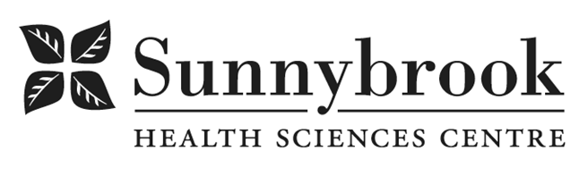

Hemodialysis Technologist

Competition # |  |  | Location: | Bayview
Classification: |  | Temporary Full-time (1 Year) | Department: | Bayview, CNIB & St.John’s
Salary: |  |  | Union: | Non-Union
Hours of Work: | Days, Evenings, Alternate Weekends, 8 hrs; as per schedule

Summary of Duties
As a member of the inter-professional team providing person centred care, the Dialysis Technologist will work closely with Hemodialysis Team
The Dialysis Technologist is responsible for the
- maintenance of the Hemodialysis machines and water treatment systems at all 3 sites
- monitor and ensure service to dialysis machines and water treatment systems meet industry standards;
- Service and maintenance of CRRT Machines (PrismaFlex & PrisMax)
- able to independently prepare dialysis machines for acute and in-centre hemodialysis treatments
- participate in education, technical improvements and programmatic quality initiatives

Qualifications/Skills
- Dialysis or Biomedical Technology Diploma or related education REQUIRED
- Minimum 2 years relevant experience REQUIRED
- GAMBRO/BAXTER Artis course PREFERRED
- Strong mechanical aptitude and solid mathematical and sciences foundation
- Proficiency in computer hardware and software an asset
- Excellent communication, conflict resolution and time management skills
- Works effectively independently or within a team
- Knowledge of and ability to effectively use organizational resources
- Valid Ontario Driver’s licence and access to a vehicle to complete home visits potentially transporting small equipment
- Ability to handle heavy equipment and supplies
- Willingness to show initiative and adapt to change
- Demonstrated commitment to person centred care approach and principles

Date Posted:
Last Day for Application:

- The location and/or details in the job posting may change depending on operational needs.
- Qualified Applicants must submit both an Internal Application/Transfer Form and current Résumé to the Human Resources Department at their campus. Qualifications, skills and demonstrated satisfactory attendance and performance are considered as part of the selection process.
- Sunnybrook is committed to providing accessible employment practices that are in compliance with the Accessibility for Ontarians with Disabilities Act (‘AODA’). If you require accommodation for disability during any stage of the recruitment process, please indicate this on your Internal Application/Transfer Form.





