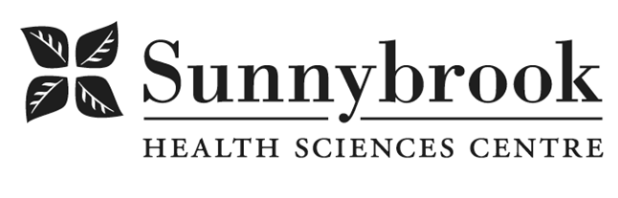

Registered Nurse

Competition # |  | Location: | Bayview
Classification: |  | Department: | Women & Babies: High Risk Obstetrics
Salary: |  | Union: | ONA
Hours of Work: 12hrs, Days, Nights, Alternating weekends
Summary of Duties
- Reporting to the Patient Care Manager, the RN is required to provide antepartum,
- Antepartum and postpartum care to women on the High Risk Obstetrics
- Required to care for women undergoing pregnancy termination and to provide perinatal bereavement care
- Required to provide care to women post gynaecological surgery
- Functions of the RN include, but are not limited to: assessment, intervention, education, patient advocacy and discharge planning
- Supports the philosophy of Family-Centred Maternity Care and the Mission & Values of Sunnybrook Health Sciences Centre
- Provides care in the context of the interprofessional team and strives to give excellent care throughout the woman’s hospital experience
- Collaborates with other members of the health care team in those activities which facilitate the operation of the unit and in providing excellent patient/family-centred health care
- Maintains all core certifications as a requirement of employment
Qualifications/Skills
- Registration with the CNO, required
- Current CPR and NRP, required
- Recent related experience in High Risk Obstetrical nursing (antepartum, postpartum), preferred
- Certification in Fetal Health Surveillance, required completion during orientation
- Recent gynaecology nursing experience, required
- Charge nurse experience, preferred
- Evidence of excellent verbal and written communication and interpersonal skills, required
- Evidence of strong customer service skills, required
- Recent related experience with Perinatal bereavement, strongly preferred
- Critical care course, strongly preferred
- Breastfeeding skills course certificate, strongly preferred (applicants will be required to successfully complete this course as a condition of employment)
Date Posted:
Last Day for Application:

- The location and/or details in the job posting may change depending on operational needs.
- Qualified Applicants must submit both an Internal Application/Transfer Form and current Résumé to the Human Resources Department at their campus. Qualifications, skills and demonstrated satisfactory attendance and performance are considered as part of the selection process.




- Sunnybrook is committed to providing accessible employment practices that are in compliance with the Accessibility for Ontarians with Disabilities Act (‘AODA’). If you require accommodation for disability during any stage of the recruitment process, please indicate this on your Internal Application/Transfer Form.

