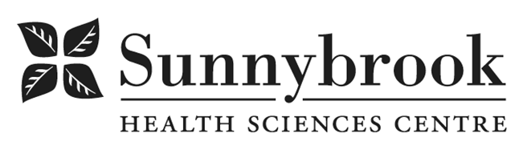
Clerical Assistant
Competition # | 210003 | Location: | St. John’s Rehab
Classification: | Part time | Department: | Outpatient Services
Salary: | $22.494 - $ 29.242/hr | Union: | SEIU-Clerical
Hours of Work: | Weekdays: Days, 8 hrs; As per schedule

The Clerical Assistant is primarily responsible for providing administrative support for the continued growth and development of Outpatient Services, which includes Marketed Services (MVC, WSIB), Wellness Clinics, and Ministry, funded Ambulatory Care Services. This incumbent provides clerical and customer services support to the Outpatient Services interdisciplinary health care team as well as third party payers and other referring partners external to the department.
Summary of Duties
- Schedule initial and treatment services which require communication with multiple internal and external team members including WSIB and insurance adjusters
- Schedule Independent Evaluation assessments in compliance with legislation standards
- Compose, edit and format the WSIB accountabilities reports monthly
- Coordinate physiatry, amputee and plastics clinics (including scheduling of assessments and follow up appointments), Recovery Garment clinics and team/client conferences
- Prepare new client charts including entering client data into the patient management systems (including Electronic Patient Record-ADT, relevant Databases)
- Composes, edits, and formats correspondence and reports; creates and amends forms
- Review new client orientation package and conduct intake sessions with new clients
- Facilitates and monitors follow-through of recommendations made in clinics (e.g. faxing of prescriptions)
- Medical transcription and billing for WSIB physician clinics
- Ongoing customer service including liaison with WSIB, insurance adjusters, rehabilitation consultants, and the client
- Participation in cross training activity related to administrative support services across Outpatient Services
- Contribute to quality improvement of the Program through participation in the development of administrative and client-care procedures
Qualifications/Skills
- Post-secondary diploma required; successful completion of a medical terminology course is preferred
- Minimum three years of administrative experience, health care or insurance setting preferred
- Insurance industry experience required (i.e. OCF 18 submissions, organizing independent medical evaluations)
- Intermediate-advanced level skill in Microsoft Outlook, Word, and Excel, as well as experience with a networked system (e.g. HCAI)
- Keyboarding at 40 w.p.m. or 106 net keystrokes per minute
- Ability to work with a minimum level of supervision and work effectively in a highly demanding environment
- Demonstrated ability to work directly with cross-functional work teams
- Demonstrated ability to prioritize and organize work, with high level of accuracy and attention to detail
- Excellent customer service skills.
- Excellent interpersonal, verbal and written communications skills.

Date Posted: January 7, 2021
Last Day for Application: January 14, 2021

- The location and/or details in the job posting may change depending on operational needs.
- Qualified Applicants must submit both an Internal Application/Transfer Form and current Résumé to the Human Resources Department at their campus. Qualifications, skills and demonstrated satisfactory attendance and performance are considered as part of the selection process.
- Sunnybrook is committed to providing accessible employment practices that are in compliance with the Accessibility for Ontarians with Disabilities Act (‘AODA’). If you require accommodation for disability during any stage of the recruitment process, please indicate this on your Internal Application/Transfer Form.





