1
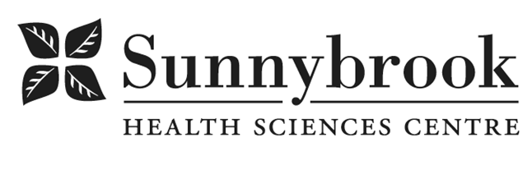
Project Manager

Competition # | TBD | Location: | Bayview Campus / Holland / St. John’s Rehab / Remote
Classification: | Full Time | Department: | Marketed Services
Salary: | TBD | Union: | Non-Union
Hours of Work: Days, 8hrs, Flexibility required

Summary of Duties:
Marketed Services at Sunnybrook Health Sciences Centre is a revenue-generating department offering a range of diverse clinical services including comprehensive assessments, surgical services, rehabilitation, treatment, mental health services and custom device manufacturing. These services are provided to clients of third-party funders including the Workplace Safety & Insurance Board, workplace employers, insurance professionals, lawyers, disability case managers, and self-pay clients.

We are currently seeking a strategic, results-driven Project Manager to support key initiatives that drive strategic growth, operational excellence, and competitive positioning within our revenue-generating services. The role is ideal for an experienced professional with a strong understanding of financial and clinical datasets and business model development, and possesses a strong understanding of the broader health system landscape related to third-party payer services. Success in this position requires the ability to collaborate effectively with multiple stakeholders, both internal and external, to execute initiatives that strengthen performance and advance organizational goals, and critical thinking to drive business growth opportunities.

The Project Manager reports to the Director of Marketed Services, and works closely with the leadership teams across programs spanning all three Sunnybrook campuses: Bayview, Holland Orthopaedic and Arthritic Centre, and St. John’s Rehab.

Key Responsibilities:
Project Management
- Develop and manage complex project plans (defining scope, clear objectives, timelines and deliverables).
- Act as project lead across cross-functional teams and programs, working as a catalyst to motivate teams on the adoption of new concepts
- Track progress, identify risks, implement mitigation strategies, and appropriately escalate project risks to leadership team to ensure project success.
- Facilitate meetings, prepare documentation, and ensure clear communication of goals and responsibilities.

Program & Business Development
- Conduct needs assessments and feasibility studies related to new business opportunities or service enhancements.
- Research market trends and competitive landscapes, identifying potential partnerships and expansion areas.
- Contribute to the development of request for proposals, and business cases.
- Collaborate with operational leaders to develop profit analysis, workflow design, and clinical models of care to support service expansion opportunities.
- Support the review of clinical and administrative workflows to identify opportunities for optimization and standardization.
- Develop and maintain key program performance indicators, prepare dashboards and status reports, share insights with leadership.

Qualifications:
- Master’s degree in Business Administration, Health Administration, or equivalent combination of education, training and experience
- Minimum 5 years’ experience in complex healthcare program
- Proven track record of driving initiatives that generate revenue or increase operational performance in a healthcare setting
- Strong analytical skills with ability to support the development of business models, financial projections, and ROI analyses
- Knowledge of WSIB, insurance legislation, and third-party assessment and treatment practices preferred
- Demonstrated ability to lead projects with multiple stakeholders
- Proven ability to manage multiple, complex initiatives within tight timelines
- High level of initiative, independence, and self-direction
- Exceptional communication, presentation, and relationship-building skills
- Experience working with internal and external stakeholders and navigating complex healthcare environments

Date Posted: TBD
Last Day for Application: TBD

- The location and/or details in the job posting may change depending on operational needs.
- Qualified Applicants must submit both an Internal Application/Transfer Form and current Résumé to the Human Resources Department at their campus. Qualifications, skills and demonstrated satisfactory attendance and performance are considered as part of the selection process.
- Sunnybrook is committed to providing accessible employment practices that are in compliance with the Accessibility for Ontarians with Disabilities Act (‘AODA’). If you require accommodation for disability during any stage of the recruitment process, please indicate this on your Internal Application/Transfer Form.




