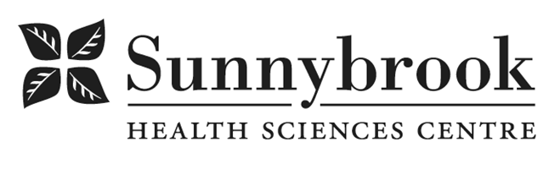

Total Rewards Specialist

Competition # : |  | Location: | All campuses as required
Classification: | Regular Full-Time | Department: | Human Resources
Salary: | $39.80 to 51.074 | Union: | Non-Union
Hours of Work: Weekdays, Days, 8 hrs, Flexibility Required

Reporting to the Manager of Benefits and working closely with the Manager, Compensation, Engagement, and HR Strategy, this role provides comprehensive total rewards support for a designated portfolio. Focusing on people solutions and programs, this role will support and enhance the total rewards framework by assisting the Manager of Benefits in overseeing group benefits, pension and streamlining HR operations to drive organizational efficiency. This role must work effectively across the People portfolio, regularly collaborating with HR team members and Occupational Health and Safety to support the broader organizational and HR strategy.
Summary of Duties
- Responsible for implementation, communication and day-to-day administration of total rewards systems/programs.
- Lead the preparation and validation of monthly benefits billing, performing comprehensive audits to ensure employee data in the HRIS perfectly aligns with third-party provider records; investigate and resolve all discrepancies in remittances, premiums, and internal benefits logs to maintain financial and data integrity.
- Responsible for investigation and resolution of compensation and benefits related inquiries.
- Respond to compensation and benefits surveys within the Hospital network on behalf of Sunnybrook.
- Support the HR Operations team through the development and maintenance of standard operating procedures (SOPs) and continuous process improvement initiatives.
- Facilitate long term disability application and follow-up processes, including meeting with staff and/or their family members to address questions regarding LongTerm Disability and Life Insurance process and claims update.
- Support employees through retirement process, including meeting with staff pre-retirement, at retirement and post-retirement to discuss full range of retirement issues such as HOOPP, CPP, and retiree benefits.
- Assist in large-scale projects underway related to HRIS implementation, utilizing a knowledge of best practices, analysis of external comparators, and knowledge of healthcare organizational structure.
- Administer the application process for life insurance eligibility and claims with the hospital’s life insurance carrier.

Qualifications/Skills
- Bachelor’s degree required with preference given to Business Management or Human Resources majors.
- A post-graduate certificate Human Resources Management.
- A minimum of 2-3 years of progressive experience in a Human Resources department.
- Preference given to unionized and healthcare experience.
- Strong working knowledge of compensation, benefits, and pension topics and relevant legislation.
- Strong ethical principles and an understanding of confidentiality.
- Excellent analytical and problem-solving skills with high level of accuracy and attention to detail.
- Experience working with cross-functional teams and building consultative relationships with leaders, HR partners, and external vendors.
- Demonstrated excellent written communication with proven customer service skills and superior, empathetic communication skills.
- Demonstrated independence and comfort in taking initiative on resolving issues within scope of responsibility.
- Ability to manage multiple priorities in a fast-paced environment.
- Advanced proficiency in Excel, PowerPoint, and Word, with strong analytical skills to manage complex data and reconciliations.
- Experience with HRIS systems, Empath or Workday is an asset.

Date Posted:
Last Day for Application:

