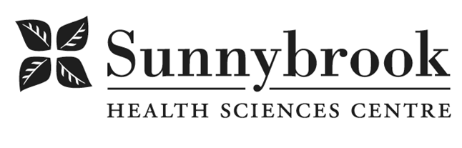

Patient Administrative Associate

Competition # | 231554 | Location: | Bayview
Classification: | Regular Full-time | Department: | Veterans Centre- LGSW
Salary: | $24.178 - $27.467/hr | Union: | SEIU – Clerical
Hours of Work: Weekdays: Days; 8 hrs; As per schedule

Summary of Duties
The PAA is responsible for the coordination of patient flow and patient activities, administrative services for the patient care unit, and maintenance of patient records, staffing, scheduling and payroll, as well as administrative support to the patient care units. The PAA will provide coverage support to other Veteran Centre units as required.

Qualifications/Skills
- One year of Community College required, Medical Terminology course preferred
- One year of Administrative/Business experience in a healthcare setting required
- Previous experience working with the elderly preferred
- Advanced computer skills and knowledge of software packages such as Microsoft Word and Windows • Demonstrated knowledge of ESP and Dimensions staff scheduling systems and unionized scheduling practices preferred
- Typing at 40 net words per minute or keyboarding at 106 net keystrokes per minute
- Patient and Family focused care philosophy
- Ability to organize work effectively, and work at a fast pace in an unpredictable environment that requires the ability to manage multiple tasks
- Excellent problem-solving and communication skills
- Excellent telephone/customer service skills
- Demonstrated ability to follow established routines
- Demonstrated ability to work successfully in a team environment.

Date Posted: April 24, 2023
Last Day for Application: May 3, 2023

- The location and/or details in the job posting may change depending on operational needs.
- Qualified Applicants must submit both an Internal Application/Transfer Form and current Résumé to the Human Resources Department at their campus. Qualifications, skills and demonstrated satisfactory attendance and performance are considered as part of the selection process.
- Sunnybrook is committed to providing accessible employment practices that are in compliance with the Accessibility for Ontarians with Disabilities Act (‘AODA’). If you require accommodation for disability during any stage of the recruitment process, please indicate this on your Internal Application/Transfer Form.





