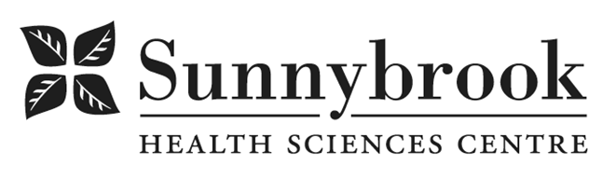
Recreation Therapist

Competition # |  | Location: Bayview D2/K3E
Classification: | Temporary Part-Time  (0.4 FTE) | Department: | Senior Friendly (Quality & Patient Safety)
Salary: |  | Union:  Non-union
Hours of Work: Full-time
Summary of Duties
- Assess, design, implement, and evaluate therapeutic recreation services for patients in Acute Care in collaboration with the interprofessional team.
- Integrate evidence-informed delirium prevention strategies into recreation therapy assessments, care plans, and interventions (e.g., orientation, cognitive stimulation, mobility, sleep–wake cycle support, and meaningful engagement).
- Utilize therapeutic recreation interventions to reduce known delirium risk factors, including social isolation, sensory impairment, immobility, and cognitive decline.
- Collaborate with the interprofessional team to support hospital-wide delirium prevention initiatives and promote non-pharmacological approaches to cognitive health.
- Provide consultation and education to staff, patients, and caregivers related to therapeutic recreation and delirium prevention best practices.
- Act as a liaison for various community partnerships to support continuity of care and cognitive wellness.
- Participate in Recreation Therapy professional initiatives, quality improvement activities, and best-practice development related to older adult care and delirium prevention.
- Document findings following best practice guidelines utilizing Sunnycare and excel

Qualifications/Skills
- Degree in Recreation /Leisure Studies with therapeutic recreation specialization;
- R/TRO designation required;
- CPR Certification at the Basic Rescuer level essential;
- Membership with a Recreation Therapy Professional Association essential;
- CTRS Designation Preferred
- Cognitive Support/Mental Health experience an asset;
- Experience working with older adults essential;
- Strong interpersonal skills, with the ability to communicate effectively at all levels both within the organization and the community;
- Demonstrated awareness of, or involvement in, current issues in the Recreation Therapy profession at a provincial or national level;
- Ability to work with the multidisciplinary team and multiple health professions on clinical and program development issues;
- GPA certificate an asset

Date Posted: ASAP
Last Day for Application:

- The location and/or details in the job posting may change depending on operational needs.
- Qualified Applicants must submit both an Internal Application/Transfer Form and current Résumé to the Human Resources Department at their campus. Qualifications, skills and demonstrated satisfactory attendance and performance are considered as part of the selection process.
- Sunnybrook is committed to providing accessible employment practices that are in compliance with the Accessibility for Ontarians with Disabilities Act (‘AODA’). If you require accommodation for disability during any stage of the recruitment process, please indicate this on your Internal Application/Transfer Form.

