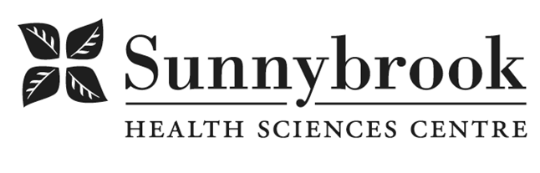
Supervisor, Health Records

Competition # | 220947 | Location: | Bayview
Classification: | Regular Full-Time | Department: | Health Records & Patient Registration
Salary: | $32.574-$41.615/hr | Union: | Non-Union
Hours of Work: | Weekdays: Days; 8hrs; As per schedule  On Call Required

Summary of Duties
- Responsible for maintaining the security, confidentiality, completeness, and accuracy of Personal Health
- Information and all associated patient registration information in accordance with policies and procedures and related legislations and guidelines.
- Participates in departmental and interdepartmental committees and provides input
- Supervises and coordinates the work activities of departments within Health Records as assigned such as:
- Release of Information, Patient Registration, Chart Management, Research, Transcription, etc.
- Implements and modifies processes and procedures as applicable.
- Participates in the development and implements policies to preserve the confidentiality of information contained in the medical records and the Registration System and monitors compliance.
- Provides support with the testing and implementation of new applications or upgrade to existing departmental applications.
- Liaise with internal and external stakeholders/agencies as required.
- Responsible for coordination and controlling all activities related to departmental systems including, but not limited to quality audit control of all registration activities.
- Develops and implements a quality assurance program, tracks and reports quality assurance results to leadership and makes recommendations for improvements Identifying training and development needs within the department.
- Lead and develop systems and processes which create organized and efficient and efficient manner.
- Maintain and monitor the day to day operational needs of the department in an effective and efficient manner.
- Demonstrate leadership to ensure quality, accuracy and timelines of departmental projects and tasks.
- Participate in hiring of staff, training, participate with performance appraisals and disciplinary action in accordance with hospital policies.
- Provide coverage for management team as required.
- Participate with after hour pager support as required
- Participate with system downtime support as required (may include after hour /week ends)
- Other duties as assigned.

Qualifications/Skills
- Completed Diploma in Health Information Management (HIM) from an accredited college, required
- Certification in Health Information Management with the Canadian Health Information Management Association (CHIMA), required
- Active member in good standing with CHIMA
- Five (5) years progressive Health Records experience required; ROI, Chart Completion, Chart management
- Knowledge of relevant legislation governing Personal Health Information e.g., PHIPA, PHA required;
- Excellent verbal and written communication skills required;
- Excellent interpersonal skills required;
- Ability to use good judgment when assessing a situation required.
- Clear knowledge and understanding of the hospital’s account structure and ADT system.
- Strong written and verbal communication skills and the ability to communicate effectively with all levels of staff.
- Outstanding customer services skills is essential.
- Excellent analytical and problem solving skills with attention to details.
- Demonstrated satisfactory performance and attendance record.
- Demonstrated ability to function in a changing and sometimes stressful work environment.
- Excellent organization skills
- Able to work independently and in a team environment.

Date Posted: March 25, 2022
Last Day for Application: April 1, 2022

- The location and/or details in the job posting may change depending on operational needs.
- Qualified Applicants must submit both an Internal Application/Transfer Form and current Résumé to the Human Resources Department at their campus. Qualifications, skills and demonstrated satisfactory attendance and performance are considered as part of the selection process.
- Sunnybrook is committed to providing accessible employment practices that are in compliance with the Accessibility for Ontarians with Disabilities Act (‘AODA’). If you require accommodation for disability during any stage of the recruitment process, please indicate this on your Internal Application/Transfer Form.





