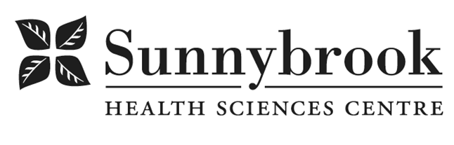
Clinical and Professional Leader – Respiratory Therapy

Competition # |  | Location: | Bayview Campus
Classification: | Regular Full-Time | Department: | Tory Trauma Program
Salary: |  | Union: | Non Union
Hours of Work: | Monday – Friday, Days, Flexibility required

Position Summary:
We are seeking a dynamic individual to lead the advancement of Respiratory Therapy (RT) within an interprofessional context. The Clinical and Professional Leader of Respiratory Therapy promotes Sunnybrook’s mission, vision and values across the organization to provide the highest quality person-centred care. The ideal candidate is passionate about the importance of innovative care, education, quality improvement/scholarship/research and working with high performing teams.
Summary of Duties:
The Clinical and Professional Leader of Respiratory Therapy reporting in a matrix structure to the Operations Director of the Tory Trauma Program, Directors of Interprofessional Practice/Education and working collaboratively with the Manager and the Physician Lead for Respiratory Therapy, will advance practice and education for RT working within adult populations.

Practice and Leadership
The Clinical and Professional Leader will provide practice and educational development, mentorship and support of operations, quality and strategic planning. They will be responsible for integrating the organization’s strategic priorities and principles for the profession; ensuring credentialing and continuing competency of the RTs. In collaboration with other programs and interprofessional leaders the Clinical and Professional Leader will develop, promote and role model evidence based and best clinical practices, both within the organization and in partnership across the health system. They will lead and champion the integration of person & family centered care initiatives. They will look for opportunities to initiate and lead quality improvement projects with support from the Critical Care Quality Committee and Physician Lead for quality improvement. In collaboration with the Manager, they will provide day-to-day coordination of the RT operations, will chair the RT Council, and represent the profession at the Health Professions Leadership Committee in addition to other corporate committees.

Education
The Clinical and Professional Leader will provide RTs and other health professionals with continuing education and professional development opportunities. They will actively participate in the development and implementation of new clinical practice guidelines and facilitate the orientation of new staff. They will act as Clinical Coordinator for the profession and will be the liaison with academic institution(s).

Equipment
The Clinical and Professional Leader, in collaboration with the RT Equipment Technician, manages daily operations for equipment procurement, equipment maintenance and inventory management for the RT department.
They provide technical expertise and oversight, track equipment quality throughout the product lifetime, make recommendations for alternatives and maintain relationships with vendors. The Clinical and Professional reports all day-to-day activities to the Manager.

Qualifications/Skills
- Member in good standing of the College of Respiratory Therapists of Ontario
- Registered with the Canadian Board of Respiratory Care
- Current BCLS certificate
- Masters degree in health related field preferred, undergraduate degree required
- Minimum 3 years recent acute care clinical experience
- Demonstrated ability to lead quality improvement projects
- Demonstrated knowledge and practice of strong adult education principles
- Demonstrated excellent collaboration/interprofessional skills
- Demonstrated satisfactory job performance and attendance

Date Posted:
Last Day for Application:

- The location and/or details in the job posting may change depending on operational needs.
- Qualified Applicants must submit both an Internal Application/Transfer Form and current Résumé to the Human Resources Department at their campus. Qualifications, skills and demonstrated satisfactory attendance and performance are considered as part of the selection process.




- Sunnybrook is committed to providing accessible employment practices that are in compliance with the Accessibility for Ontarians with Disabilities Act (‘AODA’). If you require accommodation for disability during any stage of the recruitment process, please indicate this on your Internal Application/Transfer Form.

