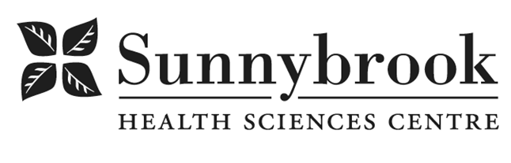

Social Worker

Competition # |  |  | Location: | Bayview
Classification: | Pro rated full time 0.8 FTE |  | Department: B1 Multidisciplinary Outpatient clinics
Salary: |  |  | Union: |  | Non-Union
Hours of Work: |  | Weekdays (Flexibility required)
The B1 Multidisciplinary Outpatient Clinic at Sunnybrook Health Sciences Centre has an exciting opportunity for an experienced Social Worker to work 0.8FTE utilizing broad SW expertise. Patients’ needs to be addressed in this outpatient area include post-operative medical follow-up, congestive heart failure, non-malignant hematology, thromboembolism, endocrine and family practice.

Summary of Duties

Reporting to the Patient Care Manager, the Social Worker (SW) in the outpatient clinics works within an inter-professional team to provide safe, effective and supportive care to a variety of patient populations.

The Social Worker works within an inter-professional team to provide a full range of social work services including psychosocial assessments, resource referrals, Advance Care Planning and Goals of Care conversations, counselling and system navigation.

The SW will champion patient advocacy, while also demonstrating exceptional leadership, communication, problem-solving and conflict resolution skills.

Responsibilities:
- Conducting Psychosocial assessments, case management, consultation and system navigation across the continuum of care, including end of life
- Counselling individuals and/or families
- Act as a resource to the inter-professional team, patients and families regarding social work services and scope of care provided
- Maintain and upgrade skills and knowledge through continuing education.
- Good understanding and application of the SW Standards of Practice
- Actively participate in inter-professional and clinical education activities
- Actively participate in, meetings and initiatives
- Commitment to Student Education

Qualifications/Skills
- Master Degree in Social Work required
- Must be a current member of the Ontario College of Social Workers and Social and in cial Service Workers in Good Standing
- Minimum two (2) years of experience working in a Hospital setting and/or
Outpatient ambulatory care setting
- Knowledge of legislation related to health care context of practice
- Experience in facilitating ACP and GoC conversation preferred
- Experience in CBT/DBT, Brief Solution Focused Therapy, Narrative Therapy
And/or Family Therapy
- Experience in System Navigation (resources and referrals)
- Good understanding of Social Determinants of Health and impact on patient
care
- Experience and commitment to quality improvement initiatives
- Excellence and demonstrated competency in the full scope of SW Practice
- Proven excellent assessment, counselling and problem solving skills essential
- Demonstrated knowledge of organizational priorities
- Ability to manage multiple tasks and set priorities in multiple clinical settings
- Superior communication, negotiation, conflict resolution, mediation
and collaborative inter-professional team skills required
- Well-established knowledge of relevant health care system processes
and community resources required
- Superior time management, organization, and prioritization skills in addressing multiple
tasks and timelines in a fast-paced environment required
- Proven commitment to person and family-centered care essential
- Ability to balance collaborative practice with self-direction

Date Posted:
Last Day for Application:

- The location and/or details in the job posting may change depending on operational needs.
- Qualified Applicants must submit both an Internal Application/Transfer Form and current Résumé to the Human Resources Department at their campus. Qualifications, skills and demonstrated satisfactory attendance and performance are considered as part of the selection process.




- Sunnybrook is committed to providing accessible employment practices that are in compliance with the Accessibility for Ontarians with Disabilities Act (‘AODA’). If you require accommodation for disability during any stage of the recruitment process, please indicate this on your Internal Application/Transfer Form.

