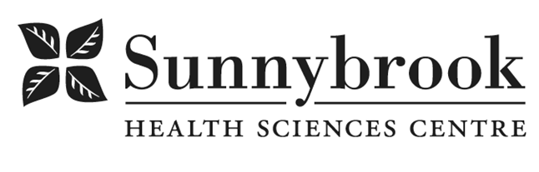

Nurse Practitioner (NP) – Pine Villa

Competition # |  | Location: | Reintegration Unit – Pine Villa
Classification: | Regular Full-Time | Department | Pine Villa
Salary: | $50.270-$64.223/hr | Union: | Non-Union
Hours of Work: Days, 8 hrs, Flexibility in hours will be required

We are seeking two dynamic Nurse Practitioners (NP) who demonstrate a high level of autonomy and expert skill to support high quality care and transition planning for adult and frail seniors at Pine Villa. Pine Villa is a 68 bed, supportive transitional care site, located in the Eglinton and Bathurst area. It is a novel approach integrating teams from the community and acute care. The NP’s at Pine Villa care for an adult and geriatric client population following admission to hospital with an acute illness. Now medically stable and designated alternate level of care (ALC), awaiting long term discharge planning (i.e. rehab, convalescent Long Term Care (LTC), clients reside in a community setting. The NP is the Most Responsible Provider (MRP) for most clients at Pine Villa.

The NP is responsible for leading the provision of person centred care, as a part of a collaborating member of the Pine Villa team. The NP will complete comprehensive assessments, order diagnostic tests and implement therapeutic plans of care for the management of care for patients with complex care needs. The ideal candidate is passionate about the importance of innovative professional practice, interprofessional teamwork, best practices, quality improvement, continuing professional development, the student experience, academic scholarship and demonstrates a commitment to the communities we serve.

The care at Pine Villa is provided by community providers SPRINT and LOFT. The LOFT population of patients includes older adults and seniors with chronic mental health, addiction issues and responsive behaviours. SPRINT clients are medically stable with ongoing issues of dementia, frailty and responsive behaviours.

Summary of Duties
- Practices within the full scope of the Nurse Practitioner role conducting assessments, developing diagnoses and therapeutic plans of care.
- Promotes wellness and health promotion in order to provide exemplary quality, safe care through the application of advanced clinical and theoretical knowledge and skills.
- Demonstrates sound clinical reasoning and current evidence in decision making, planning and implementing care.
- Collaborates with Interprofessional Team in coordinating and providing care for patients.
- Utilizes skilled communication with patients, families, healthcare providers, and partners, to support coordinated, compassionate care, including Advance Care Planning and goals of care conversations.
- Integrates best practices and evidence into clinical practice.
- Serves as a resource and consultant to administration in decision-making, strategic planning and problem-solving processes.
- Continuously identifies areas of improvement and provides leadership for quality improvement initiatives.
- Leads evaluation of outcomes, in collaboration with the Interprofessional Team, and program leaders.
- Builds partnerships with community and external stakeholders to support care planning and continuity of care.
- Supports education and development of the interprofessional team

Qualifications/Skills:
- Current College of Nurses of Ontario registration in the Extended Class (EC) as an NP (adult) or NP (primary health care) required
- Master in Nursing/Nurse Practitioner (MN-NP) or Masters of Science in Nursing with successful completion of a post Master's Acute Care Nurse Practitioner Certificate Program from a recognized school of graduate studies required
- 1-3 years relevant acute medicine or primary care experience
- Additional specialty geriatric education and experience with seniors and frail elderly preferred
- Experience in caring for seniors or those with mental health issues is an asset
- Current CPR
- Training in P.I.E.C.E.S.TM and Gentle Persuasive Approach is an asset
- Demonstrated experience through roles of advanced practitioner, educator, researcher and leader
- Demonstrated strong communication and interpersonal skills
- Possesses highly developed analytical, problem solving and critical thinking skills
- Excellent oral, written, and presentation skills, with demonstrated competency in information and communication technology

Date Posted;
Last Day for Application:

Requirements:
- The location and/or details in the job posting may change depending on operational needs.
- Qualified Applicants must submit both an Internal Application/Transfer Form and current Résumé to the Human Resources Department at their campus. Qualifications, skills and demonstrated satisfactory attendance and performance are considered as part of the selection process.
- Sunnybrook is committed to providing accessible employment practices that are in compliance with the Accessibility for Ontarians with Disabilities Act (‘AODA’). If you require accommodation for disability during any stage of the recruitment process, please indicate this on your Internal Application/Transfer Form.





