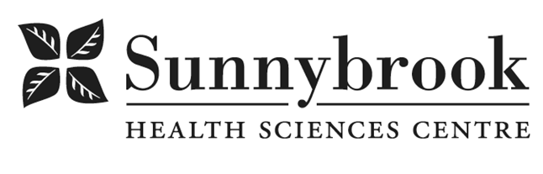

Occupational Therapist

Competition# | 230144 | Location: |  |  | Bayview Campus
Classification: | Reduced Full Time (Prorated) (0.8 FTE) |  | Department: |  | GG Mental Health
Salary: | $38.8840 – $48.622/hr |  | Union: | Non Union
Hours of Work: Weekdays, Days, 8 hrs; as per schedule

Summary of Duties
Responsible for providing Occupational Therapy inpatient services to adolescents and adults receiving Mental Health care. Conducts assessments of occupational performance and provides individualized therapy toward patient’s recovery goals, focused on daily living skills and routines, independence, well-being, and self-management/coping strategies. Collaborates with other team members to facilitate 2 – 3 therapeutic group sessions daily. Collaborates with patients, families and team members to coordinate patient care and discharge and transition planning. In support of Sunnybrook’s full affiliation with the University of Toronto, participates in teaching occupational therapy students on an ongoing basis including acting as a preceptor for fieldwork placements; supervision of one or two student placements annually is expected.

Qualifications/Skills
- Registration with the College of Occupational Therapists of Ontario required
- Membership in CAOT or OSOT
- Experience working with patients with severe and persistent Mental Illness
- Non-Violent Crisis Intervention certification
- CBT and DBT training preferred
- Ability to work to full scope, including physical and cognitive assessment, and addressing functional mobility
- Experience in integrated care, working with system partners in transition planning and demonstrate understanding of community resources to support community living
- Ability to work independently and collaboratively within an interprofessional team
- Basic knowledge of psychotropic medications and impact on functioning
- Excellent oral and written communication skills
- Ability to assist in research, program evaluation and support unit initiatives
- Demonstrated effective interpersonal skills
- Demonstrated problem-solving skills
- Strong skills in time-management and organization, professionalism and conflict resolution
- Commitment to clinical excellence and use of Best Practices
- Demonstrated commitment to Person-Centred Care approach and principles
- Ability to demonstrate reflective practice

Date Posted: January 19, 2023
Last Day for Application: January 26, 2023

- The location and/or details in the job posting may change depending on operational needs.
- Qualified Applicants must submit both an Internal Application/Transfer Form and current Résumé to the Human Resources Department at their campus. Qualifications, skills and demonstrated satisfactory attendance and performance are considered as part of the selection process.
- Sunnybrook is committed to providing accessible employment practices that are in compliance with the Accessibility for Ontarians with Disabilities Act (‘AODA’). If you require accommodation for disability during any stage of the recruitment process, please indicate this on your Internal Application/Transfer Form.





