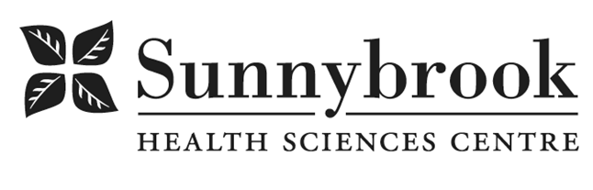

Total Rewards Specialist

Competition # : |  | Location: | All campuses as required
Classification: | Regular Full-Time | Department: | Human Resources
Salary: | $36.65 to 43.98 | Union: | Non-Union
Hours of Work: Weekdays, Days, 8 hrs, Flexibility Required

Reporting to the Manager of Benefits and working closely with the Manager, Compensation, Engagement and HR Strategy to provide total rewards support for their designated portfolio. Focusing on people solutions and programs they will support and enhance total rewards, specifically administering the retriement and long term diasbility processes for the organization. This role must work effectively with all areas in the people portfolio, regularly collaborating with HR team members, and Occupational Health and Safety, in support of the Organization and HR Strategy.
Summary of Duties
- Responsible for implementation, communication and day-to-day administration of total rewards systems/programs.
- Ensure the maintenance of accurate and consistent compensation and benefits information in Sunnybrook’s HRIS for designated portfolio.
- Responsible for investigation and resolution of compensation benefits and vacation related inquiries.
- Respond to compensation and benefits surveys within the Hospital network on behalf of Sunnybrook
- Assist in multiple large-scale projects underway related the total rewards program, utilizing a knowledge of best practices, analysis of external comparators, and knowledge of healthcare organizational structure.
- Assist employees through retirement process, including meeting with staff pre-retirement, at retirement and post-retirement to discuss full range of retirement issues such as HOOPP, CPP, and retiree benefits.
- Work in conjunction with Organizational Development to plan and host retirement benefits related sessions.
- Concudct biweekly, and monthly reporting for our third party benefit providers to ensure maintenance of accurate data and remittances andf accurately maintain various internal benefits logs, including retiree and sick leave reports.
- Facilitate long term disability application and follow-up processes, including meeting with staff and/or their family members to address questions regarding LongTerm Disability and Life Insurance process and claims update.
- Coordinate application process for life insurance eligibility and claims with the hospital’s life insurance carrier.

Qualifications/Skills
- Bachelor’s degree required with preference given to Business Management or Human Resources majors
- A post-graduate certificate Human Resources Management
- A minimum of 2-3 years of progressive experience in a Human Resources department
- Preference given to unionized and healthcare experience
- Experience with HRIS and data management, ability to turn data into a story
- Strong ethical principles and an understanding of confidentiality
- Ability to manage multiple projects and prioritize tasks
- Ability to analyze problems and provide solutions
- Experience in leading HR programs and projects, including change management responsibilities.
- Demonstrated excellent written communication with proven customer service skills and superior, empathetic communication skills
- Demonstrated independence and comfort in taking initiative on resolving issues within scope of responsibility

Date Posted:
Last Day for Application:

