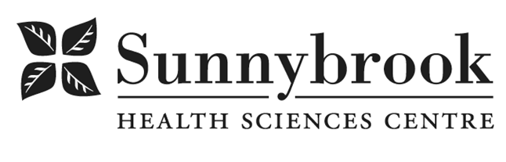
Senior Medical Laboratory Assistant-Specimen Management

Competition # |  | Location: | Bayview Campus
Classification: | Regular Full Time | Department: | Laboratory – Specimen Management
Salary: |  | Union: | OPSEU - Labs
Hours of Work: | Days, and as required per schedule, Evenings, Nights, Weekends, On-Call, Statutory Holidays,

Summary of Duties:
- Contributes to departmental processes such as budget, performance appraisals and interviews
- Assists Management with staff scheduling when required and distribution of available shifts
- Organize workflow and delegate responsibilities as required
- Networking with internal/ external organizations
- Implement senior management policies
- Ensure flow of ideas, information and instructions between staff and management
- Support of the team in carrying out functions and ensure the team understands role and responsibilities
- Ensure team member confidentiality
- Demonstrate advanced knowledge base in Specimen Management Centre
- Review/ develop procedures Standard Operation Procedure (SOP) for specimen handling/ processing
- Oversee troubleshooting and maintenance of equipment in SMC i.e. Centrifuge, Pneumatic tube system
- Awareness of the implications of errors and generation of incident reports as required
- Ensure that all policies and procedures are followed and adhered to according to acceptable standards established by the Quality Management System (QMS), senior staff, licensing and accreditation bodies i.e. Accreditation Canada Diagnostics (IQMH)
- Collaboration with the departmental TQM team
- Develop and implement procedures for the evaluation of the technical competencies in collaboration with the Quality Assurance Officer (QAO) and colleagues
- Develops training plans and assists in orientation of new staff and continuing education of current staff
- Attend appropriate professional development sessions
- Maintain MLPAO competency standards

Qualifications/Skills:
- Successful completion Community College Medical Laboratory Technician Program
- MLPAO certification required
- Minimum five (5) years relevant experience as a medical laboratory assistant required, hospital setting required
- Advanced computer skills including Word, EXCEL, PowerPoint
- Demonstrated experience with technology
- Demonstrated excellent communication (both written and oral), interpersonal and organizational skills
- Demonstrated ability to work effectively, organize workload, and adjust to varying work assignments as needed
- Critical thinking skills
- Ability to organize and direct work of others
- Demonstrated ability to prepare comprehensive reports
- Knowledge of quality assurance
- Knowledge of privacy regulations related to confidential information
- Demonstrated knowledge of WHMIS, Transportation of Dangerous Goods (TDG), infection control procedures and Safety

Date Posted: Dec 31 2024
Last Day for Application:

- The location and/or details in the job posting may change depending on operational needs.
- Qualified Applicants must submit both an Internal Application/Transfer Form and current Résumé to the Human Resources Department at their campus. Qualifications, skills and demonstrated satisfactory attendance and performance are considered as part of the selection process.
- Sunnybrook is committed to providing accessible employment practices that are in compliance with the Accessibility for Ontarians with Disabilities Act (‘AODA’). If you require accommodation for disability during any stage of the recruitment process, please indicate this on your Internal Application/Transfer Form.





