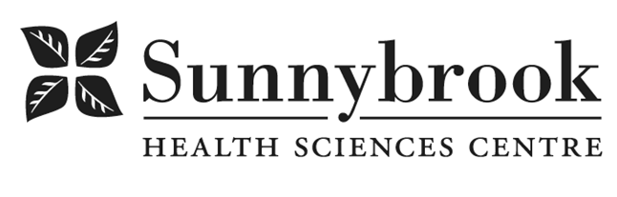

Speech-Language Pathologist – last updated Jan 2025

Competition # |  |  | Location: | Bayview
Classification: |  |  | Department: | Veteran’s Centre
Salary: |  |  | Union: | Non-Union
Hours of Work: |  | Weekdays, Days, 8 hrs; as per schedule
Summary of Duties
Sunnybrook Health Sciences Centre has an opportunity for a Speech-Language Pathologist (SLP) to provide services to residents and patients in the transitional care and palliative care in the Veterans Centre. The fast-paced, mixed caseload includes swallowing and communication services. The successful candidate will work collaboratively with interprofessional teams to provide evidence-informed best practice.

Responsibilities Include:
- Assess swallowing and communication; plan, implement and monitor swallowing and communication interventions in a timely manner
- Provide education and counselling for residents, patients and caregivers regarding communication and/or swallowing difficulties and strategies
- Manage complex discharges within a transitional care program, including education to patients and caregivers, and referring to community programs and services as needed
- Maintain and upgrade skills and knowledge through continuing education and seek opportunities for knowledge dissemination
- Maintain resident/patient records, workload measurement and MDS statistics in accordance with facility and professional standards
- Participate in clinical and interprofessional education activities in support of the Graduate Department of Speech- Language Pathology at the University of Toronto
- Provide supervision to Communicative Disorders Assistant, in collaboration with other members of the Speech-Language Pathology team
- Participate in SLP Professional Council, Program and hospital-wide meetings, committees and planning as required
- Practice in accordance with the College of Audiologists and Speech-Language Pathologists of Ontario

Qualifications/Skills
- Current CASLPO registration
- Previous experience working with geriatric, medically complex, and palliative populations

Demonstrated effective ability to:
- Assess and provide treatment/interventions for dysphagia and communication impairments
- Foster a collaborative relationship with the Communication Disorders Assistant (CDA) including providing clinical supervision to a CDA through appropriate referrals and ongoing goal setting
- Provide effective and timely videofluoroscopic evaluation
- Provide comprehensive discharge planning including referring patients to community services and programs
- Provide clinical education to health care professionals; providing presentations and in-services is preferred
- Work collaboratively as a member of interprofessional teams, including CDA
- Maintain and upgrade skills and knowledge through continuing education
- Manage multiple priorities in the context of a large complex caseload

Date Posted:
Last Day for Application:

