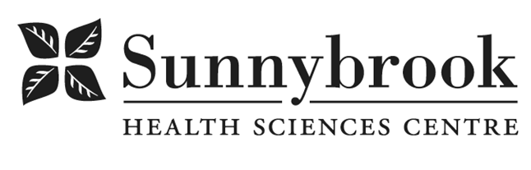
Advanced Practice Nurse

Competition # | XXXXX | Location: | Bayview Campus
Classification: | Temporary Full Time | Department: | Veteran’s Program - Complex Medical Support, K1W & K2W
Salary: |  | Union: | Non Union
Hours of Work: | 8hrs, Days; Flexibility required
Summary of Duties:
The Advanced Practice Nurse (APN) is responsible for integrating and advancing clinical excellence by identifying, applying and evaluating best practices as defined within the Veterans Program, Sunnybrook Health Sciences Centre, and the broader nursing community. The APN facilitates learning and evidence based practice implementation and evaluation within the Program by working with groups of nurses in a supportive manner. The APN also plays a role in knowledge creation and dissemination through research and quality improvement initiatives.
We are seeking an experienced, dynamic and innovative APN with expertise and practice focus in complex chronic disease management to join our team to support our Complex Medical Support patient population - patients with complex needs who do not need acute care, but cannot be supported in other settings / still require temporary specialized support.
Working collaboratively with others, and reporting to the Director of Operations for the program, the successful candidate will:
- Demonstrate and facilitate system leadership
- Mentor, support, and work to advance nursing practice in geriatrics
- Work with assigned teams and groups of nurses in an inter-professional model
- Provide consultation to others as needed
- Engage in evaluation and research activities
- Develop, promote, and role model evidence-based and best clinical practices
- Lead and champion the integration of person- & family-centered care initiatives
- Collaborate effectively with inter-professional health care team members

Qualifications/Skills:
- Required current Ontario College of Nurses Certificate of competence and BCLS certificate.
- Completed Master’s degree studies required in health related discipline or Nursing (preferred)
- Nursing leadership experience with demonstrated effective leadership and team work abilities
- 5 years previous acute care experience
- Previous experience with dialysis modalities preferred
- previous experience with geriatrics preferred
- Canadian Nurses Association certification in relevant specialty considered a definite asset.
- Proven well-developed organizational, time management skills; flexible and adaptable to change and adjusting priorities.
- Established ability to integrate the concept of person-centered care into direct & indirect clinical practice.
- Demonstrated successful track record with change management including effective implementation, evaluation and supporting / sustaining positive change.
- Excellent interpersonal and communication skills (oral, written and comprehension) working collaboratively within the inter-professional team.

Date Posted: XXX
Last Day for Application: XXXX

- The location and/or details in the job posting may change depending on operational needs.
- Qualified Applicants must submit both an Internal Application/Transfer Form and current Résumé to the Human Resources Department at their campus. Qualifications, skills and demonstrated satisfactory attendance and performance are considered as part of the selection process.




- Sunnybrook is committed to providing accessible employment practices that are in compliance with the Accessibility for Ontarians with Disabilities Act (‘AODA’). If you require accommodation for disability during any stage of the recruitment process, please indicate this on your Internal Application/Transfer Form.

