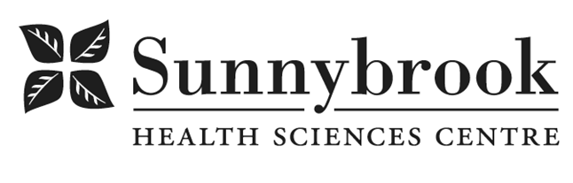
Advanced Practice Nurse
Competition # |  | Location: | Bayview Campus
Classification: | Regular Full-Time | Department: | Integrated Community Program –  D2 Nephrology/ General Medicine
Salary: |  | Union: | Non-Union
Hours of Work: 8hrs, Days; Flexibility required
After hours and weekends as required

Summary of Duties:
The Integrated Community Program seeks a dynamic Advanced Practice Nurse to facilitate processes to support excellence in patient-centered practice based on relevant best practice, conceptual frameworks, research literature and professional standards of practice, legislative requirements, and other scholarly resources. The Advanced Practice Nurse (APN) is responsible for integrating and advancing clinical excellence by identifying, applying and evaluating best practices as defined by Sunnybrook Health Sciences Centre, and the broader nursing community. The APN facilitates learning and evidence based practice implementation and evaluation by working with groups of nurses in a supportive manner. The APN also plays a role in knowledge creating and dissemination through research and quality improvement initiatives.
Through a holistic and integrated approach, the APN works with members of the inter-professional team, patients and their families to provide comprehensive care. Working collaboratively with the Patient Care Manager, APNs, Educators, and members of the inter-professional team and reporting to the Director of Operations for the program, the successful candidate will:

- Demonstrate and facilitate system leadership
- Mentor, support, and work to advance nursing practice
- Work with assigned teams and groups of nurses in an inter-professional model
- Educate Nephrology Nursing staff on Peritoneal Dialysis.
- Provide consultation to others as needed regarding care approaches and responsive behaviors
- Work to create and maintain a safe working environment
- Engage in evaluation, quality improvement and research activities, advancing best practices, evaluate quality of care, and support professional development of staff.
- Develop, promote, and role model evidence-based and best clinical practices
- Lead and champion the integration of person-centered care initiatives
- Collaborate effectively with interprofessional health care team members
- Influence clinical scholarship at the point of care by leading development and exchange of knowledge related to clinical specialty
- Lead orientation and ongoing education for the nursing tem integrating education best practices and theory

Qualifications/Skills:
- Knowledge and experience in Peritoneal Dialysis required.
- Knowledge, skills, and experience in adult education, program design, teaching, group facilitation, team work and conflict management.
- Proficient computer skills.
- Current College of Nurses of Ontario Certificate of Competence.
- Current BCLS certificate.
- Master’s degree in Nursing or health-related discipline (completed or in progress preferred).
- National certification in Nephrology from the Canadian Nurses Association preferred.
- A strong desire to promote professional practice and excellence in evidence-based, patient centered care.
- Superior interpersonal, coaching, and leadership skills to facilitate identification and development of staff learning needs.
- Committed to excellence in all aspects of the discipline including professional practice, research and education.
- Proven well- developed organizational, time management skills; flexible and adaptable to change and adjusting priorities
- Established ability to integrate the concept of person-centered care into direct & indirect clinical practice
- Demonstrated successful track record with change management including effective implementation, evaluation and supporting/sustaining positive change
- Excellent interpersonal and communication skills (oral, written and comprehension) working collaboratively within the inter-professional team
- Membership in the Registered Nurses’ Association of Ontario, preferred.
- Minimum of five (5) years of relevant nursing experience.
- Self-motivated, able to cope with several projects at one time.
- Flexible with change and able to set priorities and problem-solve.

Date Posted:
Last Day for Application:

- The location and/or details in the job posting may change depending on operational needs.
- Qualified Applicants must submit both an Internal Application/Transfer Form and current Résumé to the Human Resources Department at their campus. Qualifications, skills and demonstrated satisfactory attendance and performance are considered as part of the selection process.
- Sunnybrook is committed to providing accessible employment practices that are in compliance with the Accessibility for Ontarians with Disabilities Act (‘AODA’). If you require accommodation for disability during any stage of the recruitment process, please indicate this on your Internal Application/Transfer Form.




