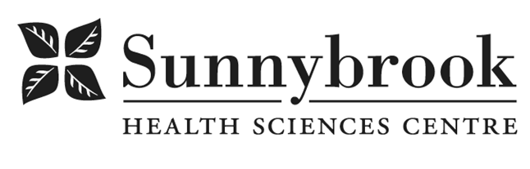
Project Manager

Competition # |  | Location: | Bayview Campus
Classification: | Temporary Full Time, Two Years | Department: | Hurvitz Brain Sciences Program
Salary: |  | Union: | Non-Union
Hours of Work: Days, 8hrs, Flexibility required

Summary of Duties:

Sunnybrook has an immediate need for a Full-time Project Manager, supporting the development of a dementia care strategy. Sunnybrook will be a transformative leader in dementia care, integrating cutting-edge research with comprehensive clinical care, expanding access to advanced biomarkers and novel therapies, and ensuring supports are in place for patients and their families, alongside community integration. The position will focus on working with key stakeholders to develop a comprehensive plan for achieving this vision, including a governance structure and project plan, with key performance indicators and outcome measures to evaluate our impact. We are looking for an experienced health system professional that possesses a strong understanding of the broader health system landscape, funding and accountability, along with knowledge of hospital operations. The ideal candidate will have experience in developing sustainable solutions for complex health system issues across multiple stakeholders.

This role will report to the Operations Director of the Hurvitz Brain Sciences Program and the Co-Chairs of the Dementia Care Strategy Taskforce, and will engage with individuals throughout the organization including other leaders, physicians, external partners, and front line staff.

- Project Management:
  - Contribute to defining the scope and priorities for Sunnybrook in the context of the overall system strategy;
  - Develop and manage complex project plans (defining plans with clear objectives and timelines);
  - Lead multiple work streams across clinical programs (including content development to ensure sustained momentum) with support from Director;
  - Identify, mitigate, and appropriately escalate project risks to ensure project success to Director;
  - Report / monitor deliverables, timelines across multiple work streams;
  - Utilize data from various sources and summarize succinctly for executive level decision making;
  - Appropriately connect clinical and financial information to drive initiatives forward.

- Change Management:
  - Guide others to prepare for, support and adopt actions required to achieve successful outcomes;
  - Facilitation of large groups meetings and processes to ensure objectives are achieved;
  - Work collaboratively with stakeholders across the health system, including internal and community partners to design, implement and evaluate the impact of key organizational priorities;
  - Working as catalyst to motivate and to adopt new concepts;
  - Influence to gain acceptance of ideas and proposals through persuasion and interpersonal skills;
  - Establish and maintain collaborative partnerships with individuals across a broad range of organizational levels;

Qualifications/Skills

- Master’s degree in Business Administration, Health Administration or equivalent combination of education, training and experience
- Minimum 3 years hospital experience or equivalent
- Proficiency using Microsoft Office programs, primarily Excel and PowerPoint
- High level of initiative and self-direction
- Ability to manage multiple, complex initiatives within tight timeframes
- Comfort in situations where the goal or process to achieve those goals is unclear
- Have a strong understanding of the health care environment including funding methodologies and hospital data structures (clinical and financial)

Date Posted: TBD
Last Day for Application: TBD

- The location and/or details in the job posting may change depending on operational needs.
- Qualified Applicants must submit both an Internal Application/Transfer Form and current Résumé to the Human Resources Department at their campus. Qualifications, skills and demonstrated satisfactory attendance and performance are considered as part of the selection process.
- Sunnybrook is committed to providing accessible employment practices that are in compliance with the Accessibility for Ontarians with Disabilities Act (‘AODA’). If you require accommodation for disability during any stage of the recruitment process, please indicate this on your Internal Application/Transfer Form.




