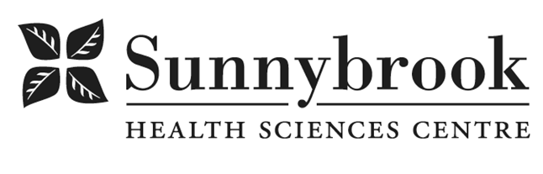
Nutrition Technician
Last updated Feb 26 2025

Competition # |  | Location:
Classification: |  | Department: | Veterans Centre
Salary: |  | Union:
Hours of Work:

Sunnybrook Health Sciences Centre has an exciting opportunity to pilot a Nutrition Technician (NT) position within the transitional care units in the Veterans Program. This NT will be providing clinical services to transitional patients admitted to K1W, K2W, DMH, and LSSE. The successful candidate will work collaboratively with the interprofessional team, including Registered Dietitians and Food Service Supervisors, to provide evidence-informed best practices in clinical nutrition, while supporting the principles of person-centered care and the vision, mission and values of Sunnybrook Health Sciences Centre.

Summary of Duties
- Identify appropriate patients for care through case-finding, assessments and by referrals
- Establish and/ implement nutrition care plans for patients at low and medium nutritional risk, and collaborate with the Registered Dietitian to care for moderate- high nutrition risk patients.
- Modify selected therapeutic diet orders and meals according to allergies, intolerances, preferences, and Registered Dietitian/Speech Language Pathologist recommendations using CBORD system
- Receive and provide transfer of accountability for caseload as patients are admitted, transitioned and discharged
- Complete calorie count as appropriate
- Provide nutrition education to patients and families for selected therapeutic diets
- Participate in education of dietetic interns and other students as applicable
Qualifications/Skills
- Successful completion of a CSNM accredited program in Food Services Administration and Technology or a Bachelor’s degree in Nutrition from a university recognized in Dietetics
- Clinical experience required
- Experience using CBORD food services/nutrition management software
- Experience using Point Click Care preferred
- Experience assessing, implementing and managing nutrition care and therapeutic diets required
- Ability to work effectively in a person centered care environment in various clinical settings as a member of the interprofessional team, managing multiple demands and changing priorities
- Experience in providing nutrition education to patients, families and interprofessional team members
- Self-directed and initiative, with the ability to work independently is essential
- Superior communication, collaboration and teamwork skills
- Demonstrated organizational skills and ability to effectively prioritize work
- Demonstrated ability to be flexible and adaptable

